Assignment 1

2023-01-29

#Dataset source: https://www.kaggle.com/datasets/imdevskp/corona-virus-report  
library(readr)  
SL_country_wise_latest <- read.csv("~/Downloads/archive (2)/country_wise_latest.csv")

#Showing the chosen Dataset  
summary(SL_country_wise_latest)

## Country.Region Confirmed Deaths Recovered   
## Length:187 Min. : 10 Min. : 0.0 Min. : 0.0   
## Class :character 1st Qu.: 1114 1st Qu.: 18.5 1st Qu.: 626.5   
## Mode :character Median : 5059 Median : 108.0 Median : 2815.0   
## Mean : 88131 Mean : 3497.5 Mean : 50631.5   
## 3rd Qu.: 40460 3rd Qu.: 734.0 3rd Qu.: 22606.0   
## Max. :4290259 Max. :148011.0 Max. :1846641.0   
## Active New.cases New.deaths New.recovered   
## Min. : 0.0 Min. : 0.0 Min. : 0.00 Min. : 0.0   
## 1st Qu.: 141.5 1st Qu.: 4.0 1st Qu.: 0.00 1st Qu.: 0.0   
## Median : 1600.0 Median : 49.0 Median : 1.00 Median : 22.0   
## Mean : 34001.9 Mean : 1223.0 Mean : 28.96 Mean : 933.8   
## 3rd Qu.: 9149.0 3rd Qu.: 419.5 3rd Qu.: 6.00 3rd Qu.: 221.0   
## Max. :2816444.0 Max. :56336.0 Max. :1076.00 Max. :33728.0   
## Deaths...100.Cases Recovered...100.Cases Deaths...100.Recovered  
## Min. : 0.000 Min. : 0.00 Min. :0.00   
## 1st Qu.: 0.945 1st Qu.: 48.77 1st Qu.:1.45   
## Median : 2.150 Median : 71.32 Median :3.62   
## Mean : 3.020 Mean : 64.82 Mean : Inf   
## 3rd Qu.: 3.875 3rd Qu.: 86.89 3rd Qu.:6.44   
## Max. :28.560 Max. :100.00 Max. : Inf   
## Confirmed.last.week X1.week.change X1.week...increase WHO.Region   
## Min. : 10 Min. : -47 Min. : -3.840 Length:187   
## 1st Qu.: 1052 1st Qu.: 49 1st Qu.: 2.775 Class :character   
## Median : 5020 Median : 432 Median : 6.890 Mode :character   
## Mean : 78682 Mean : 9448 Mean : 13.606   
## 3rd Qu.: 37080 3rd Qu.: 3172 3rd Qu.: 16.855   
## Max. :3834677 Max. :455582 Max. :226.320

#Modifying the variable with logic  
SL_country_wise_latest$Recovered<-(SL_country_wise_latest$Recovered-mean(SL_country_wise_latest$Recovered)/var(SL_country_wise_latest$Recovered))  
SL_country_wise_latest$Deaths

## [1] 1269 144 1163 52 41 3 3059 711 167 713  
## [11] 423 11 141 2965 7 538 9822 2 35 0  
## [21] 2647 294 2 87618 3 347 53 6 1 22  
## [31] 0 391 8944 59 75 9187 4656 8777 7 54  
## [41] 208 115 96 139 87 19 373 613 58 0  
## [51] 1083 5532 4652 408 51 0 69 34 228 0  
## [61] 329 30212 49 8 16 9125 168 202 0 0  
## [71] 1761 45 26 20 158 0 1166 596 10 33408  
## [81] 4838 15912 4458 1764 474 35112 10 998 11 585  
## [91] 285 185 438 1301 0 31 51 12 72 64  
## [101] 1 80 112 91 99 124 15 124 9 156  
## [111] 10 44022 748 4 0 45 316 11 8 48  
## [121] 6160 22 108 69 860 466 255 393 5842 1322  
## [131] 0 43 18418 1945 1676 1719 165 2206 13334 5  
## [141] 0 0 0 42 14 2760 194 543 0 66  
## [151] 27 28 116 93 7067 300 46 28432 11 720  
## [161] 24 5700 1978 40 7 60 21 58 0 18  
## [171] 8 50 5630 148011 2 1636 345 45844 35 121  
## [181] 146 0 78 1 483 140 36

#The Histogram's display  
hist(SL_country_wise_latest$Deaths)

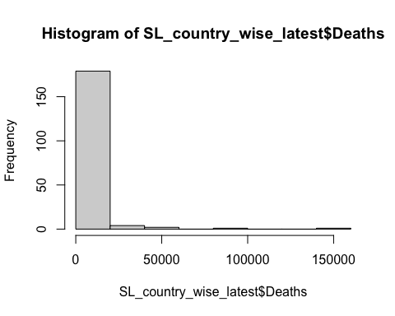

#ScatterPlot  
  
library(ggplot2)  
ggplot(SL_country_wise_latest)+  
 aes(x=Recovered,y=Deaths)+  
 geom_point(shape="circle",size=1.5,colour="#112446")+  
 theme_minimal()

